Membership Type

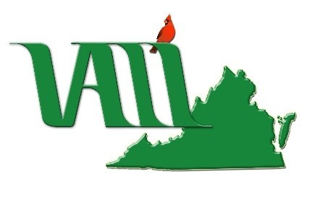 | VIRGINIA ASSOCIATION OF LAW LIBRARIES  Membership Application &  VALL Directory Update  June 1, 2024 - May 31, 2025

Individual……………………………….………………………$20.00  Extends to any resident of Virginia or its vicinity connected with a law library or library other than a law library or working as a consulting law librarian, and follows the person if he/she changes libraries. | Associate…………………..…………………………$25.00  A person not directly connected with a law library or other library, located in Virginia or its vicinity, may become an associate member, with approval of the Executive Board.
Institutional....………..………$20.00/designated staff person  Extends to a library or firm, located in the state of Virginia or its vicinity. Membership lies with the institution rather than the person; therefore, designated members may change as staff changes. Complete one copy of this page for each designated member. | Sustaining……………………………………………$50.00  Any company or institution supporting the goals of the Association may become a sustaining member with the approval of the Executive Board.  Student....……...………………………………………$7.50  An individual enrolled either in a library or law school.

Professional Information
Name:
Job title:
Place of Employment:
Directory Address:
Work Phone:
Mobile Phone:
Fax:
Home (Optional):
E-mail:
Other Memberships: | AALL SEAALL VLA SLA ALA Other (please specify)

Renew or Join at https://www.valawlibraries.org/ or Mail Check, Payable to VALL, and This Form To:

Please make checks payable to VALL and submit to VALL Treasurer Jocelyn Mitchell Manion, Fourth Circuit Library, Lewis F. Powell, Jr. U.S. Courthouse, 1000 East Main Street, 1st Floor, Richmond, VA 23219

